- Open the file hotels_test0901 and save it to your Functional skills ICT folder
- Select all column headings and click on Sort and Filter, then filter, you should get arrows at the top of every column
- Using the instruction from the previous exercise, select hotels in Italy, then when you get the results do another filter on hotels that have four starts.
- Sort the data into alphabetical order by hotel by following these instructions:
  - Select the hotel column heading
  - Click on Sort and filter and select sort A-Z
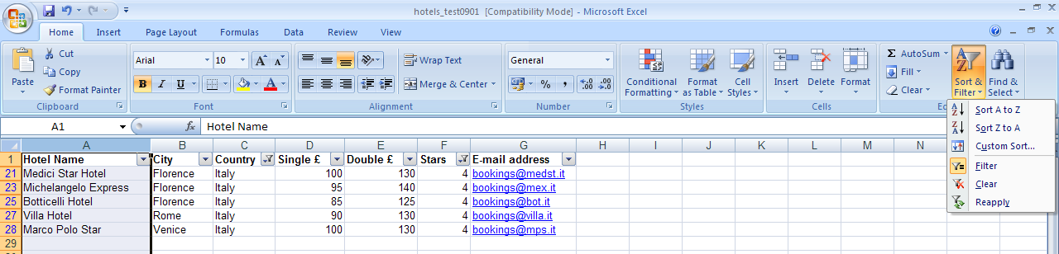
- Insert a column that shows total cost for 4 nights for a double room, insert a formula that will show that.
- Insert a suitable heading to the file
- In the footer with your name, candidate number and centre number as below
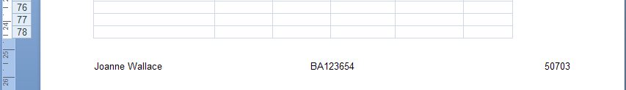
- Save your work using a suitable file name
- Change the layout to show all columns
- Print your work
- Change the view to show the formulas – click on ‘formulas’ select ‘show formulas’ then print
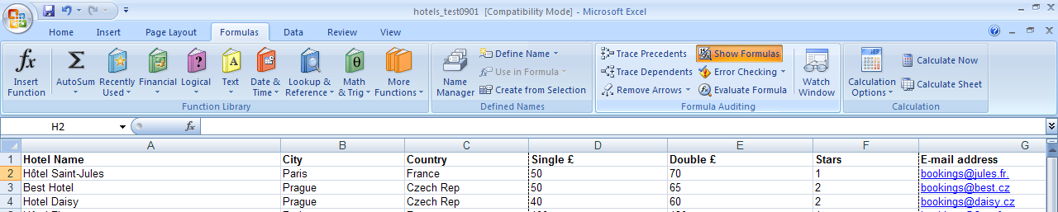
Reminder

- Check your spelling
- Use a suitable layout
- Use a suitable font

